MAHARAJA SURAJMAL INSTITUTE
Affiliated to GGSIP university & NAAC 'A' grade accredited



DEPARTMENT OF COMPUTER APPLICATIONS (IInd shift)

Web Based Programming
Subject Code: BCA-104
Semester- 2nd (Section-A)

Submitted To:
Dr. Sushma Malik
(Assistant Professor)
Submitted By:
Arjun
Enrollment no. 01821202025

Q1. Write regular expressions including modifiers, operators, and metacharacters.
<?php
$text = "Hello, My name is Arjun and my roll number is 018";
// 1. Using metacharacters (^ and $)
if (preg_match("/Hello/", $text)) {
echo "The string starts with Hello<br>";
}
if (preg_match("/\d+/", $text)) {
echo "Yes, it contains numbers<br>";
}
if (preg_match("/[A-Z]/", $text)) {
echo "Yes, it contains uppercase letters<br>";
}
if (preg_match("/\d{3}/", $text)) {
echo "Yes, it contains exactly 3 digits<br>";
}
if (preg_match("/Hello|Hi/", $text)) {
echo "Yes it contains Hello or Hi<br>";
}
if (preg_match("/hello/i", $text)) {
echo "Case-insensitive match found<br>";
}
echo "----- Actual string is: $text -----";
?>

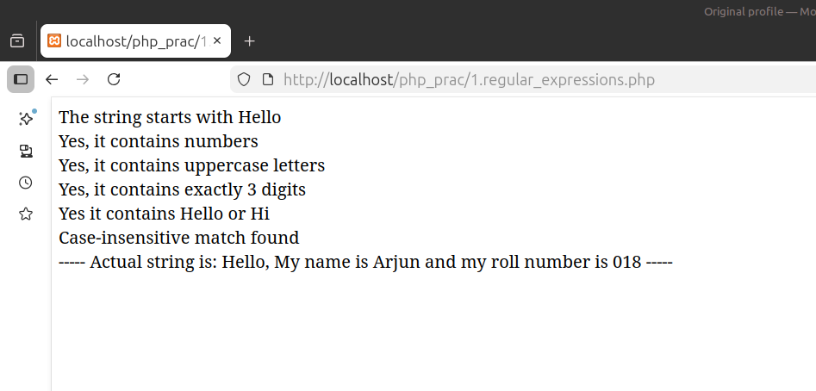

Q2. Write a program to show the usage of nested if statement
<?php
$a=10;
$b=20;
$c=3;
echo "> this program checks for the largest numbers out of three given: <br>";
echo"> given that: a=$a , b=$b , c=$c <br><br>";
if ($b > $a){
if ($b > $c){
echo "$b is largest";}
else {
echo "$c is largest";
}
}
else {
if ($a > $c){
echo "$a is largest";
}
}
?>
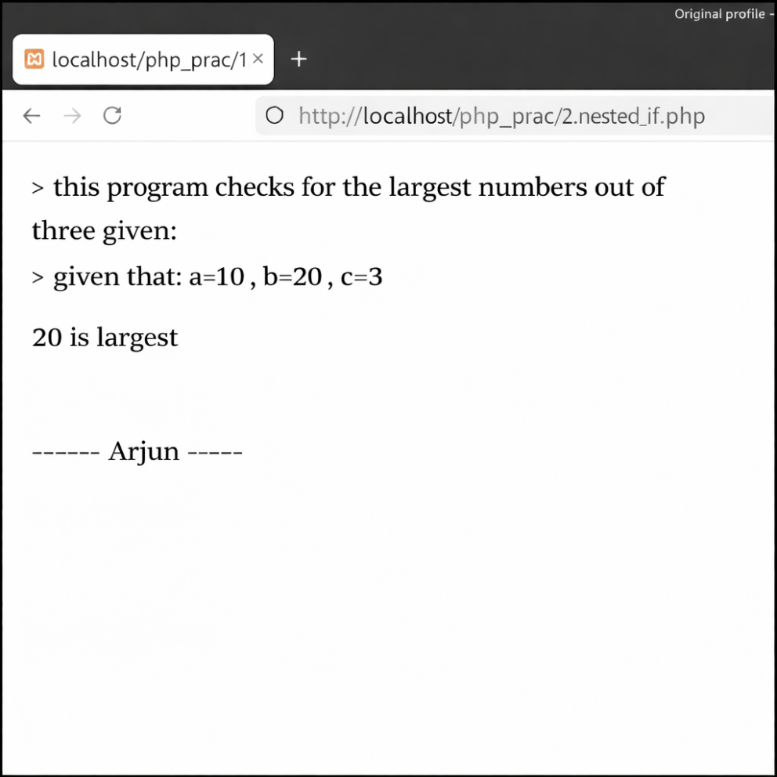

Q3. Write a Program in PHP for type Casting Of a Variables
<?php
$a = "123.45";
$b = 10;
$c = 5.75;
$d = true;
echo "Original Values: <br>";
echo "variable A = "; var_dump($a); echo "<br>";
echo "variable B = "; var_dump($b); echo "<br>";
echo "variable C = "; var_dump($c); echo "<br>";
echo "variable D = "; var_dump($d); echo "<br>";
echo "<br>After Type Casting: <br>";
$int_a = intval ($a);
echo "variable a as integer: $int_a - ";
var_dump($int_a);
echo "<br>";
$float_a = floatval ($a);
echo "variable a as float: $float_a - ";
var_dump($float_a);
echo "<br>";
$string_b = strval ($b);
echo "variable b as string: $string_b - ";
var_dump($string_b);
echo "<br>";
$int_c = (int)$c;
echo "variable c as integer: $int_c - ";
var_dump($int_c);
echo "<br>";
$int_d = (int)$d;
echo "variable d as integer: $int_d - ";
var_dump($int_d);
echo "<br>";
$bool_b = (bool)$b;
echo " variable B as boolean: $bool_b - ";
var_dump($bool_b);
echo "<br>";
echo "----- Arjun Mehrania -----";
?>

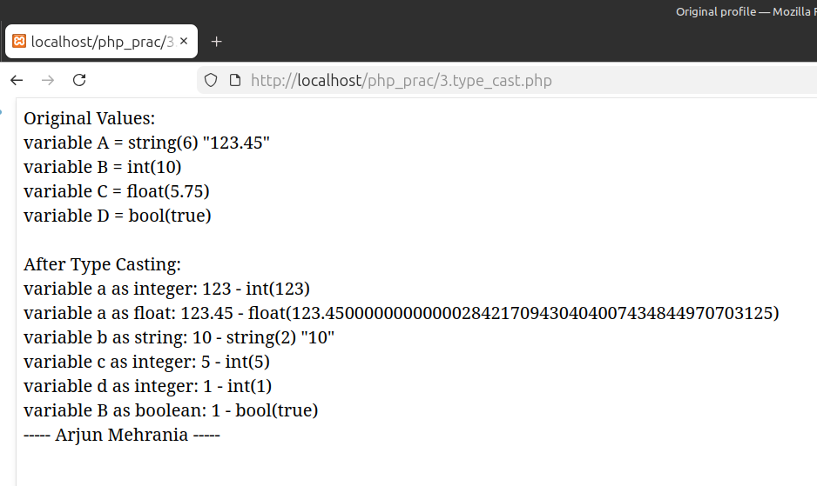
Q4. Write a program to create a menu driven program and show the usage of switch-case.
<?php
$result = "";
if (isset($_POST['choice'])) {
$choice = $_POST['choice'];
$num1 = $_POST['num1'];
$num2 = $_POST['num2'];
switch ($choice) {
case "add":
$result = "After Addition = " . ($num1 + $num2); break;
case "sub":
$result = "After Subtraction = " . ($num1 - $num2); break;
case "mul":
$result = "When Multiplication is done= " . ($num1 * $num2); break;
case "div":
if ($num2 != 0) { $result = "By Division operator = " . ($num1 / $num2); }
else { $result = "Cannot divide by zero!"; } break;
default: $result = "Invalid choice!";
} } echo "Arjun Mehrania";
?>
<!DOCTYPE html><html><head><title>Menu Driven Program</title></head><body>
<h1>Switch Case Based Calculator</h1> <form method="post">
Enter first Number: <input type="number" name="num1" required><br><br>
Enter second Number: <input type="number" name="num2" required><br><br>
<h4>Choose any Operation:</h4>
<input type="radio" name="choice" value="add"> Add<br>
<input type="radio" name="choice" value="sub"> Subtract<br>
<input type="radio" name="choice" value="mul"> Multiply<br>
<input type="radio" name="choice" value="div"> Divide<br><br>
<input type="submit" value="Calculate">
</form>
<h3>
<?php echo $result; ?>
</h3>
</body></html>

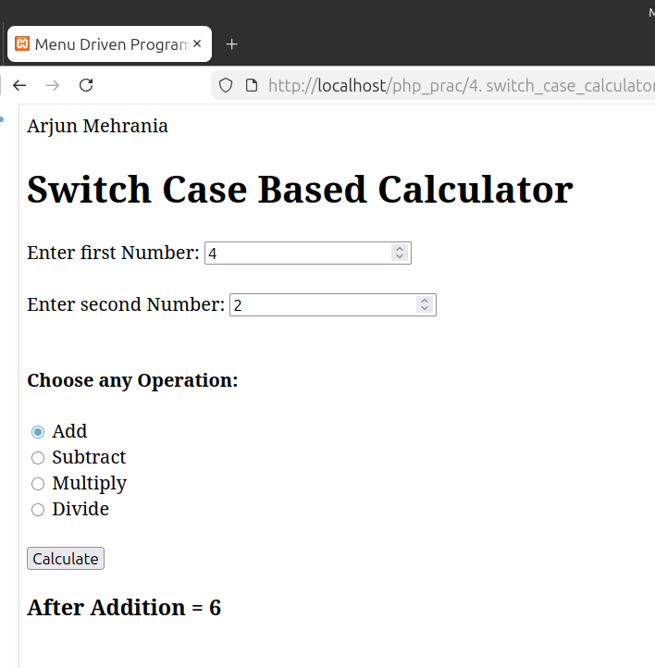
Q5. Write a program to show the usage of for/while/do while loop
<?PHP
$int=10;
echo"<b>-> using for loop</b>: We have a number $int which will keep printing unless it becomes 15 <br>";
for($i=$int;$i<=15;$i++){
echo "$i "; }
echo"<br><b>-> using while loop:</b> We have an integer $int1 which should increment and print itself until value becomes 40 <br>";
$int1=35;
while($int1 !=41){
echo "$int1 ";
$int1 ++; }
echo "<br><b>-> using do-while loop:</b> We store $int2 in variable int which will keep printing until it becomes equal to 100<br>";
$int2=91;
do{
echo "$int2 ";
$int2 ++; } while($int2 <= 100);
echo"<br><i>-> using do while loop:</i> do while loop will execute once at minimmum even if condition is false.<br>";
$int3=77;
echo"Ex- if $int3 is more than $int2, we will print it's value below:<br> ";
do{
echo "$int3";
}while($int3 > $int2);
echo "<br>----- Arjun Mehrania -----"; ?>

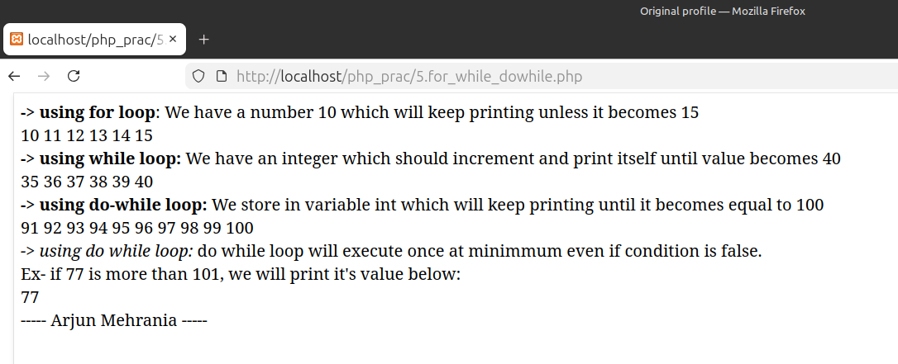
Q6. Write a program to perform all four types of sorting
<?php
$i=0;
$gaddi=array('porsche','bentley','mclaren','pagani');
echo "Original array<br>";
print_r($gaddi);
echo "<br>-------------------";
sort($gaddi);
echo"<br><br>sorting the arrays alphabetically :<br>";
for($i=0; $i<4;$i++){
echo "$i: $gaddi[$i] <br>";
}
echo "-------------------- <br><br>";
rsort($gaddi);
echo"sorting the arrays alphabetically reversed<br>";
for($i=0; $i<4;$i++){
echo "$i: $gaddi[$i] <br>";
}
echo "--------------------<br><br>";
$keemat= array('porsche'=>'2', "bentley"=>"7", 'mercedes'=>'1', "pagani"=>"10");
echo "sorting the arrays by their values (ascending)<br>";
asort($keemat);
foreach($keemat as $model=>$model_price){
echo "$model is priced at: ₹$model_price crore <br>";
}
echo "-------------------- <br><br>";
ksort($keemat);
echo"sorting arrays by their values (descending)<br>";
foreach($keemat as $model=>$model_price){
echo "$model is priced at: ₹$model_price crore <br>";
}
echo"-------------------- -------------------- ";
echo "----- Arjun Mehrania -----";
?>

Q7. Write a program to implement Array-pad(), array_slice(), array_splice(), list() functions. (use foreach wherever applicable)
<?php
$arr=array(10,20,30,40,50,60,70);
echo"<b>--></b> original array is: ";
foreach($arr as $a){
echo"$a ";
}
echo"<br>Using <b>array_slice</b> on the original array: ";
$arr_sliced=array_slice($arr,1,3);
foreach($arr_sliced as $arr_sl){
echo"$arr_sl ";
}
echo"<br>Using <b>array_splice</b> on the original array: ";
$temp=$arr;
array_splice($temp,2,3,array(21,22,23));
foreach($temp as $arr_spl){
echo"$arr_spl ";
}
echo"<br>Using <b>array_pad</b> on the original array: ";
$array_paded=array_pad($arr,10,0);
foreach($array_paded as $arr_pd){
echo "$arr_pd ";
}
echo"<br>Using <b>list method</b> on the original array: ";
list($first,$sec,$three)=$arr;
echo "$first,$sec,$three";
echo "<br>----- Arjun Mehrania -----";
?>
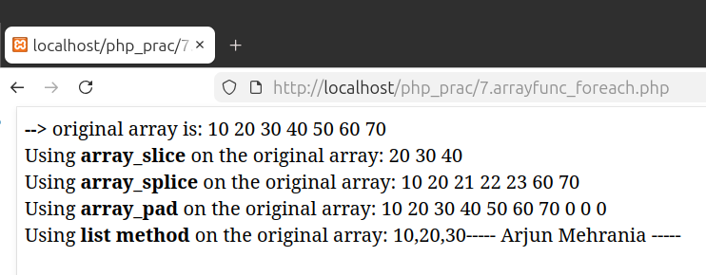

Q8. Write a program to show the application of user defined functions.
<?php
$text1='Janakpuri';
$text2="Pocket4";
function checksize($x){
return strlen($x);
}
echo "Implementing user defined functions<br>";
function greeting($name="BCA at Maharaja Surajmal Institute"){
echo "Welcome to $name ";
echo "\n";
echo "--> <i>there are ".checksize($name). " letters in the word $name</i><br>";
}
greeting($text2);
greeting($text1);
greeting();
echo "<br>----- Arjun Mehrania -----";
?>

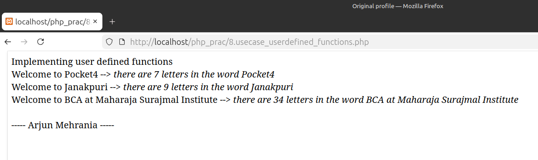

Q9. Write a program that Passes control to another page (include, require, exit and die functions)
<?php
echo "<h3>Execution starting:::</h3>";
$file_inc='page4.php';
$file_req="page5.php";
include "$file_inc";
echo "name of the car is: $car <br>";
require("$file_req");
echo "model of the car is: $model<br>";
echo"-----Arjun Mehrania-----";
exit ('<h3>Execution halted:::</h3>');
?>
<?php
echo "file has been included, ";
$car='skoda';
$car1='volkswagen';
?>
<?php
echo "required file is present, ";
$model='kushaq';
?>

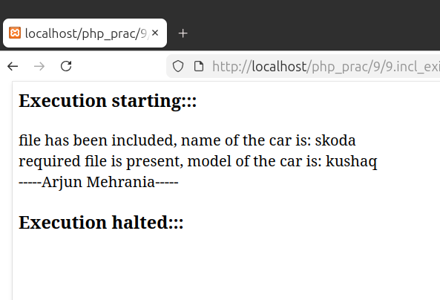

Q10. Write a program to validate the form data using Filter_var() function.
<?php
$mail='haihawai@vacation.com';
$mail_sanitize=filter_var($mail, FILTER_SANITIZE_EMAIL);
if(filter_var($mail_sanitize, FILTER_VALIDATE_EMAIL)){
echo "$mail is valid";
}
else {
echo "Invalid mail address $mail";
}
echo "<br>----- Arjun Mehrania -----";
?>

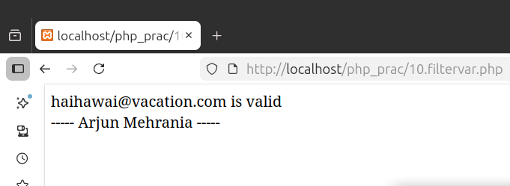

Q11. Write a program to show the usage of Cookie.
<?php
$cook_nam='test1';
$cook_val="test1val";
setcookie($cook_nam,$cook_val, time() + 3600);
if (count($_COOKIE)>0){
echo "cookies detected<br>";
}
else{
echo "no cookies found";
}
if(isset($_COOKIE[$cook_nam])){
echo "name of cookie is: $cook_nam and value is $_COOKIE[$cook_nam]";
}
else {
echo "<br>cookie not found";}
echo "<br>----- Arjun Mehrania -----";
?>

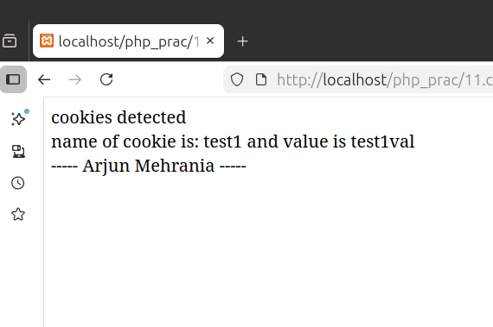

Q12. Write a program to show the usage of Session
<?php
session_start();
if (isset($_POST['set'])) {
$_SESSION["username"] = "Arjun Mehrnaia";
$_SESSION["email"] = "arjun@msi.com";
$message = "Session data has been set.";
} else if (isset($_POST['update'])) {
if (isset($_SESSION["username"])) {
$_SESSION["username"] = "Arjun0";
$_SESSION["email"]="0arjun@msi.com";
$message = "Session username and email updated successfully";
} else { $message = "No session data to update."; }
} else if (isset($_POST['destroy'])) {
session_unset(); session_destroy();
$message = "Session has been destroyed ";
}
$username = $_SESSION["username"] ?? "Not set";
$email = $_SESSION["email"] ?? "Not set";
echo "----- Arjun's Session -----";
?>
<!DOCTYPE html><html><head><title>PHP Session Usage</title></head><body>
<h2>PHP Session Example</h2>
<p><strong>Username:</strong> <?php echo $username; ?></p>
<p><strong>Mail ID:</strong> <?php echo $email; ?></p>
<p style="color:green;"><?php echo $message; ?></p>
<form method="post">
<button type="submit" name="set">Set Session</button>
<button type="submit" name="update">Update</button>
<button type="submit" name="destroy">Destroy</button>
</form></body></html>
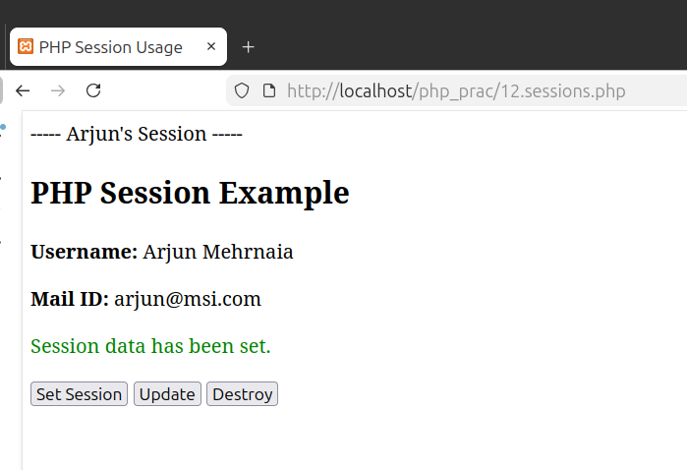
-

Q13. Write a program to implement oops concepts.
<?php
class Person {
protected $name; protected $age;
public function __construct($name, $age) {
$this->name = $name; $this->age = $age;
} public function getDetails() {
return "Name: " . $this->name . ", Age: " . $this->age;
} public function getRole() { return "I am a person."; }
} class Student extends Person {
private $course;
public function __construct($name, $age, $course) {
parent::__construct($name, $age); $this->course = $course;
} public function getRole() {
return "I am a Bachelor student of ".$this->course;
}}
class Teacher extends Person {
private $subject;
public function __construct($name, $age, $subject) {
parent::__construct($name, $age); $this->subject = $subject;
} public function getRole() {
return "I am a professor of Bachelors in " . $this->subject;
}}
$student = new Student("Arjun", 18, "Computer applications");
$teacher = new Teacher("Nitin", 81, "Arts");
echo "<h2>Concept of Object Oriented Programming in PHP</h2>";
echo "<h3>Student details:</h3>";
echo $student->getDetails() . "<br>";
echo $student->getRole() . "<br>";
echo "<h3>Teacher details:</h3>";
echo $teacher->getDetails() . "<br>";
echo $teacher->getRole() . "<br>";
echo "----- Arjun Mehrania -----";
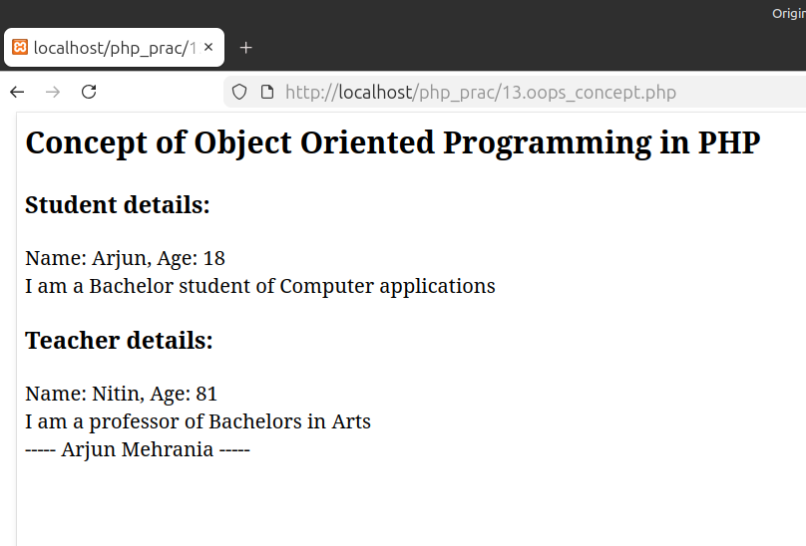
?>

Q14. Do Form handling In PHP - Design a personal Information form, then Submit & Retrieve the Form Data Using $_GET(), $_POST() and $_REQUEST() Variables
<?php
$name = $email = $gender = $course = ""; $methodUsed = "";
if ($_SERVER["REQUEST_METHOD"] == "POST") { $methodUsed = "POST";
}
elseif ($_SERVER["REQUEST_METHOD"] == "GET" && isset($_GET['submit'])) { $methodUsed = "GET";
}
if (isset($_REQUEST['submit'])) {
$name = $_REQUEST['name']; $email = $_REQUEST['email'];
$gender = $_REQUEST['gender']; $course = $_REQUEST['course'];
}
echo "----- Arjun Mhrania -----";
?>
<!DOCTYPE html><html><head><title>Information Form</title></head><body>
<h2>Personal Info Form</h2>
<form method="get">
<h3>Submit using GET</h3>
Name of the cadidate:<input type="text" name="name"><br><br>
mail of candidate:<input type="email" name="email"><br><br>
Gender of candidate: <input type="radio" name="gender" value="Male"> Male
<input type="radio" name="gender" value="Female"> Female<br><br>
Course pursuing: <select name="course">
<option value="BCA">BCA</option><option value="BBA">BBA</option>
<option value="na" selected>Choose here</option>
<option value="MCA">MCA</option></select><br><br>
<input type="submit" name="submit" value="Submit via GET">
<p>----------<p/></form>
<form method="post"><h3>Submit using POST</h3>
Name of the candidate:<input type="text" name="name"><br><br>
mail id of the candidate :<input type="email" name="email"><br><br>
Gender: <input type="radio" name="gender" value="Male"> Male
<input type="radio" name="gender" value="Female"> Female<br><br>
Course pursuing: <select name="course">
<option value="BCA">BCA</option><option value="BBA">BBA</option>
<option value="naa" selected>Choose here</option>
<option value="MCA">MCA</option></select><br><br>
<input type="submit" name="submit" value="Submit via POST">
<p>----------</p>
</form>
<?php if (isset($_REQUEST['submit'])) {
echo "<strong>Method Used:</strong> " . $methodUsed . "<br>";
if ($methodUsed == "GET") {
echo "Using $_GET - Name: ".$_GET['name']."<br>";
}
if ($methodUsed == "POST") {
echo "Using $_POST - Name: ".$_POST['name']."<br>";
}
echo "Using $_REQUEST - Name: $name, Email: $email, Gender: $gender, Course: $course";
}
?>
</body></html>

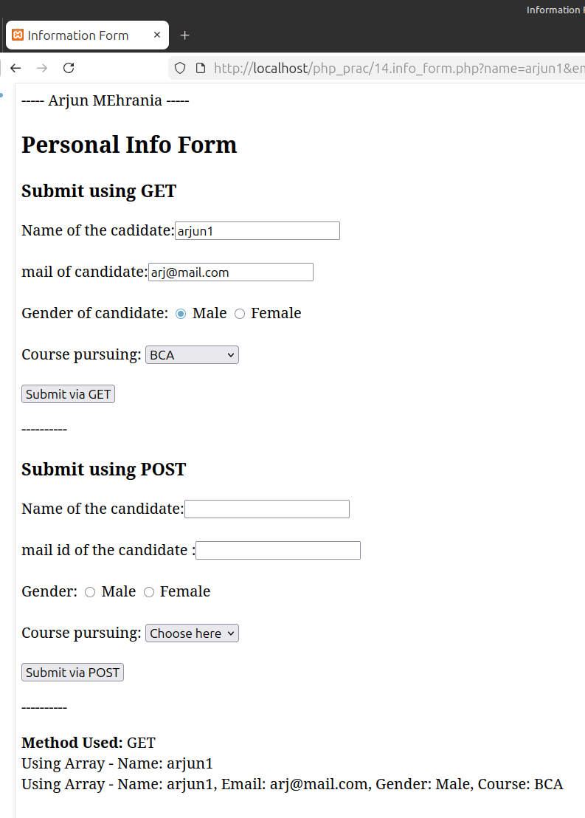
Q15. Design A Login Form and Validate that Form using PHP Programming
<?php
$username = $password = "";
$usernameErr = $passwordErr = $loginMsg = "";
$validUser = "admin"; $validPass = "12345";
if ($_SERVER["REQUEST_METHOD"] == "POST") {
if (empty($_POST["username"])) { $usernameErr = "Username is mandatory";
}
else { $username = $_POST["username"]; }
if (empty($_POST["password"])) { $passwordErr = "Password is mandatory";
}
else { $password = $_POST["password"];
}
if ($usernameErr == "" && $passwordErr == "") {
if ($username == $validUser && $password == $validPass) {
$loginMsg = "Login Successfully done";
} else { $loginMsg = "Invalid Username or Password, Try again";
}
}}
echo "----- Arjun Mehrania -----";
?><!DOCTYPE html><html><head><title>Login Form</title></head><body>
<h2>User Login Form</h2>
<form method="post">
Username: <input type="text" name="username">
<span style="color:green;">* mandatory field<?php echo $usernameErr; ?></span><br><br>
Password: <input type="password" name="password">
<span style="color:blue;">* mandatory field<?php echo $passwordErr; ?></span><br><br>
<input type="submit" value="Login">
</form><br>
<?php if ($loginMsg != "") { echo "<strong>$loginMsg</strong>"; } ?>
</body>
</html>

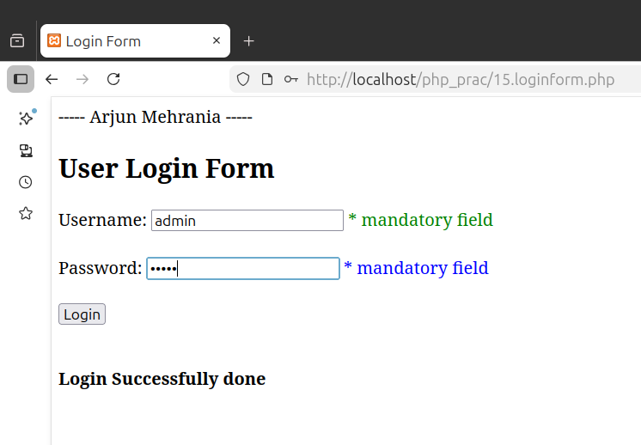

Q 00. Design A Login Form using Session and redirect to dashboard using PHP
<?php
session_start();
if ($_SERVER["REQUEST_METHOD"] == "POST") {
$username = $_POST['username'];
$password = $_POST['password'];
if ($username == "admin" && $password == "1234") {
$_SESSION['admin'] = $username;
header("Location: dashboard.php");
exit();
} else {
echo "Invalid credentials input";
}
}
?>
<form method="post">
Username of the user: <input type="text" name="username"><br>
Secured password: <input type="password" name="password"><br>
<input type="submit" value="Access dashboard">
</form>
<?php echo "----- Arjun Mehrania -----"; ?>

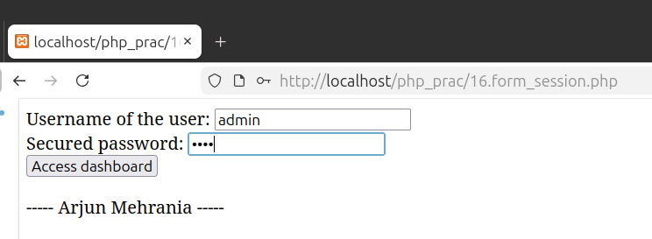
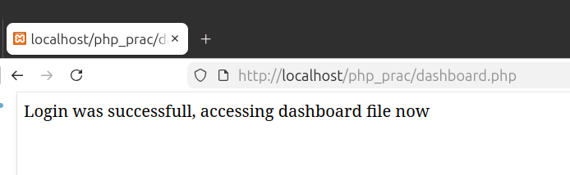
Q16. Create Admin Login, Logout form using session variables
<?php
session_start();
echo "-----Arjun Mehrania-----";
$adminUser = "admin"; $adminPass = "admin123";
$message = "";
if (isset($_POST['login'])) {
$user = $_POST['username']; $pass = $_POST['password'];
if ($user == $adminUser && $pass == $adminPass) {
$_SESSION['admin_logged_in'] = true;
$_SESSION['admin_name'] = "Arjun";
$message = "Login done successfully Welcome, Arjun.";
} else { $message = "Invalid username or password, try agian"; }
} if (isset($_POST['logout'])) {
session_unset(); session_destroy();
$message = "You have been logged out successfully";
} ?>
<!DOCTYPE html><html><head><title>Admin Login/Logout</title></head><body>
<h2>Login / Logout programme ---Arjun---</h2>
<?php if (isset($_SESSION['admin_logged_in']) && $_SESSION['admin_logged_in']): ?>
<h3>Welcome, <?php echo $_SESSION['admin_name']; ?>!</h3>
<p>Logged in as Admin</p>
<form method="post"><input type="submit" name="logout" value="Logout as Admin"></form>
<?php else: ?>
<form method="post">
Username: <input type="text" name="username" required><br><br>
Password: <input type="password" name="password" required><br><br>
<input type="submit" name="login" value="Login">
</form>
<?php endif; ?>
<p style="color:green;"><strong><?php echo $message; ?></strong></p>
</body></html>

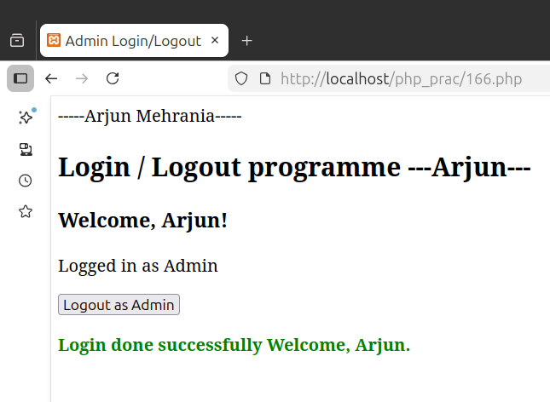

Q17. Program to create a file in PHP

<?php
echo "Using file operations to create file named: myfile.txt <br>";
$file_op=fopen("myfile.txt","w") or die("Err: method not working");
$tex="helloworldd ";
fwrite($file_op,$tex);
fclose($file_op);
echo "File operation successful";
echo "<br>-----Arjun Mehrania-----";
?>
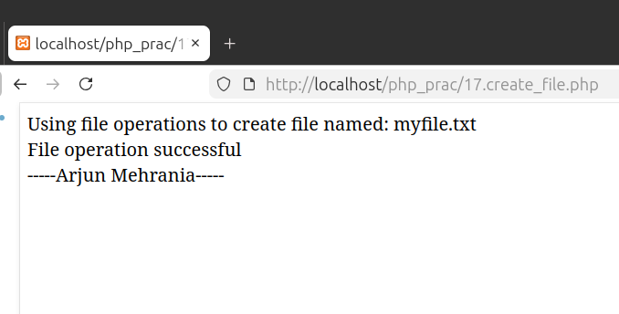

Q18. Program to read a file and display contents in PHP

<?php
echo "Using fread() method to read contents of file:";
$f_read=fopen("myfile.txt", "r") or die("<br>ERR: method not working");
$f_data=fread($f_read, filesize("myfile.txt"));
echo "<br>Content: $f_data";
//echo fread($f_read,filesize("myfile.txt"));
fclose($f_read);
echo "<br>-----Arjun Mehrania-----";
?>
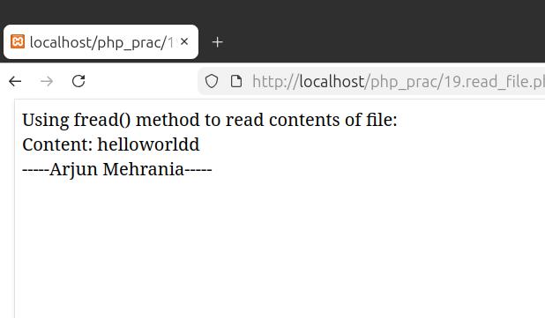

Q20. Modify contents of existing file

<?php
$f_append=fopen("myfile.txt", "a") or die("ERROR: method didn't work");
$text_app="\n This file has been appended";
fwrite($f_append, $text_app);
echo "execution successful";
fclose($f_append);
?>

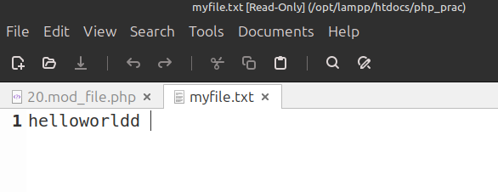

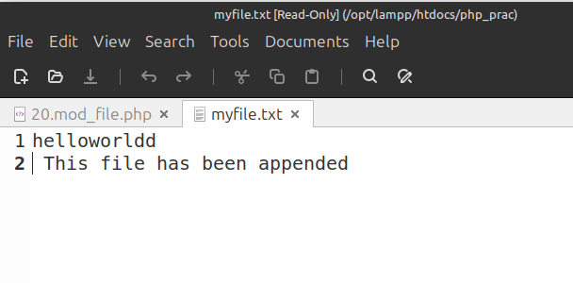

Q21. Create a web page and which provides File uploading and downloading a file.

HTML Code:
<!DOCTYPE html>
<html>
<body>
<form action="upload_file.php" method="post" enctype="multipart/form-data">
Select image to upload: <br>
<input type="file" name="filetoupload">
<input type="submit" name="submit"><br>
</form>
</body>
</html>

Php Code:
<?php
$target_folder="uploads/";
$target_dir= $target_folder . ($_FILES["filetoupload"]["name"]);
$upload=1;
if(isset($_POST["submit"])){
if(file_exists($target_dir)){
$upload=0;
echo "File already existing, " . "destination of file: $target_dir <br>";
}
else if ($upload==1){
if(move_uploaded_file($_FILES["filetoupload"]["tmp_name"], $target_dir)){
echo "File has been uploaded " . "to : $target_dir <br> ";
}
else {echo "Error uploading file" . "<br> Error code: " . $_FILES["filetoupload"]["error"];
}}}
$f_name=basename($target_dir);
$f_dir="downloads/".$f_name;
if(file_put_contents($f_dir,file_get_contents($target_dir))){
echo "image has been download at: $f_dir";
}
else {echo"error";}
echo"<br><br> -----Arjun Mehrania-----";
?>

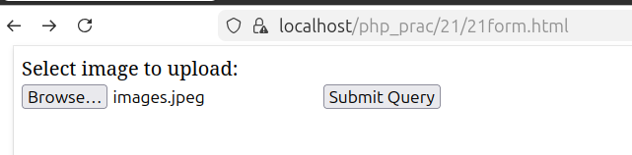

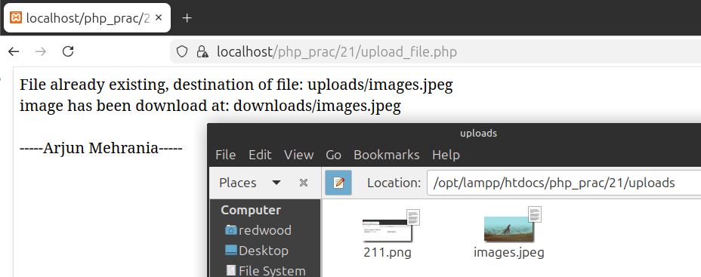

Q22. Design a from which upload And Display Image in PHP
Q23. Write a program to create a mysql database.

<html>
<body>
<h2>Upload And Display Image in PHP</h2>
<form method="POST" enctype="multipart/form-data">
Select Image:
<input type="file" name="imgfile">
<input type="submit" name="submit" value="Upload">
</form>
<?php
if(isset($_POST["submit"])){
$folder = "22/";
$file = $folder . basename($_FILES["imgfile"]["name"]);
if(move_uploaded_file($_FILES["imgfile"]["tmp_name"], $file)){
echo "<br>Image Uploaded Successfully<br><br>";
echo "<img src='$file' width='500' height='300'>";
}
else{
echo "Image not uploaded";
}}
?>
</body>
</html>

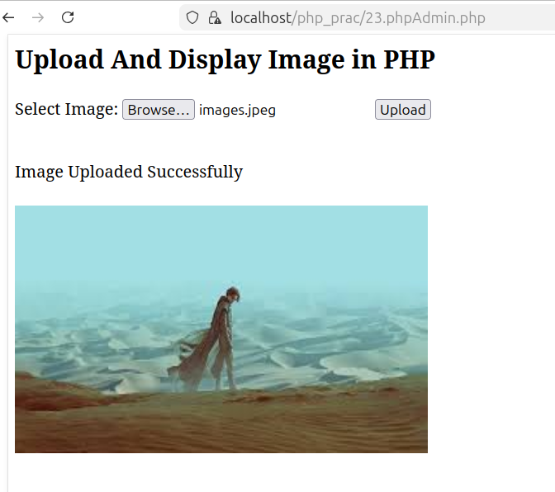

Q24. Write a program to create MySQL database

<?php
$servername = "127.0.0.1";
$username = "root";
$password = "redwood";

$conn = new mysqli($servername, $username, $password);
if ($conn->connect_error) {
die("Connection failed: " . $conn->connect_error);
}

$sql = "CREATE DATABASE myDB";
if ($conn->query($sql) === TRUE) {
echo "Database created successfully";
} else {
echo "Error creating database: " . $conn->error;
}

$conn->close();
?>

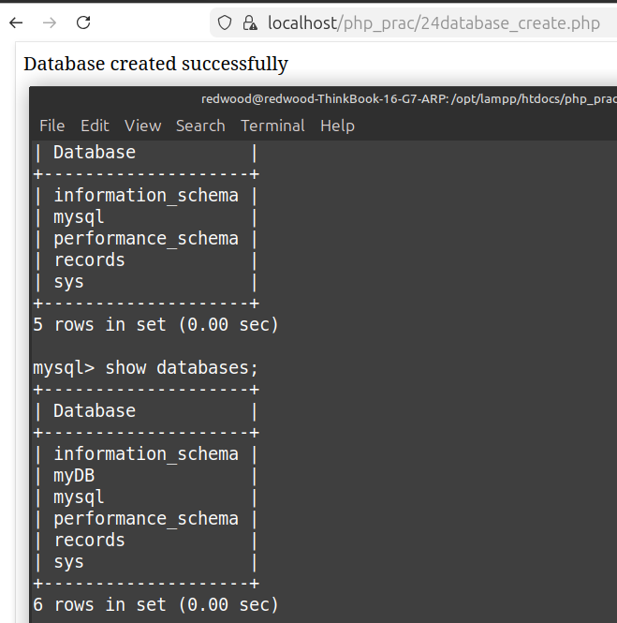
Q25. Write a program to create a table and insert few records into it using form

HTML CODE:
<html>
<head><title>PHPxMySQL</title></head>
<body>
<form action="insert_table.php" method="POST" enctype="multipart/form-data">

<h1>Students record database</h1>
<p>Enter your name: <input type="text" name="nametxt"></p>
<p>Enter your course: <input type="text" name="coursetxt"> </p>
<p><input type="submit" name="sbt"></p>

</form>
</body>
</html>

PHP Code:
<?php
$srvr="127.0.0.1";
$user="root";
$pass="redwood";
$connecting=new mysqli($srvr,$user,$pass,"records");
if($connecting -> connect_error){
echo "Erorr: ".$connecting -> connect_error;
}
else if($connecting){
echo"connection established successfully";
if(isset($_POST["sbt"])){
$course_form=$_POST["coursetxt"];
$name_form=$_POST["nametxt"];
echo " :: POST ACCESSED<br>";
$q1="use records;";
$q2="Create table IF NOT EXISTS student(Name varchar(10), Course varchar(10))";
echo "Table created successfully<br>";
$q3="Insert into student values('$name_form','$course_form')";
if($connecting->query($q3)){
echo "Records inserted successfully<br>";
} else {
echo "Error: " . $connecting->error;
}}
}
?>
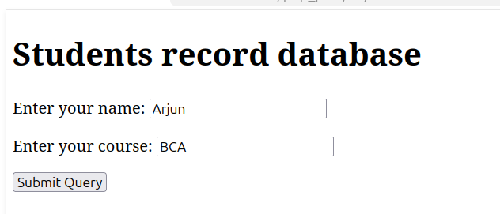

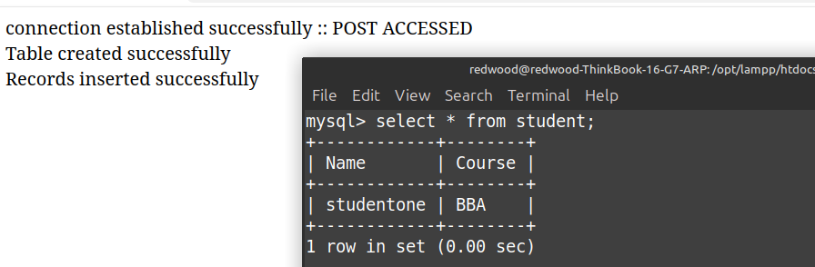
Q26. Write a program to select all the records and display it in table.

<?php
$srvr = "127.0.0.1";
$user = "root";
$pass = "redwood";
$db = "records";
$con = new mysqli($srvr, $user, $pass, $db);
if($con->connect_error){
die("Connection Failed");
}
else{
echo "Connected to the Database;<br><br><hr><br>";
}
$result = $con->query("SELECT * FROM student");
echo "<table border='1' cellpadding='8'>";
echo "<tr><th>Name</th><th>Course</th></tr>";
while($row = $result->fetch_assoc()){
echo "<tr>";
echo "<td>".$row["Name"]."</td>";
echo "<td>".$row["Course"]."</td>";
echo "</tr>";
}
echo "</table>";
$con->close();
?>

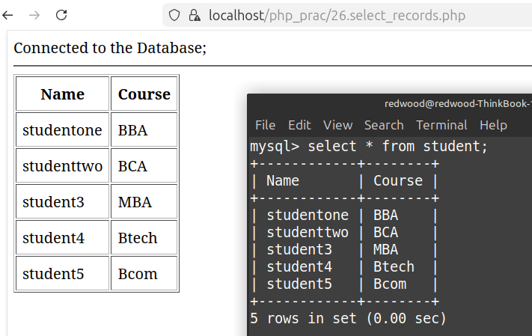
Q27. Write a program to modify (delete/modify/add) a table

<?php
$servername = "127.0.0.1";
$username = "root";
$password = "redwood";
$conn = new mysqli($servername, $username, $password, "records");
if ($conn->connect_error) {
die("Connection failed: " . $conn->connect_error);
}
$q1 = "alter table student add column age int;";
$q2 = "alter table student modify column name varchar(20);";
$q3 = "alter table student drop column age;";
if ($conn->query($q1) === TRUE) {
echo "New column 'age' added in the table<br>";
} else{ echo "Error " . $conn->error; }
if ($conn->query($q2) === TRUE) {
echo "'Name' column has been modified<br>";
} else{ echo "Error " . $conn->error; }
if ($conn->query($q3) === TRUE) {
echo "Column 'age' has been dropped";
} else{ echo "Error " . $conn->error; }
$conn->close();
?>

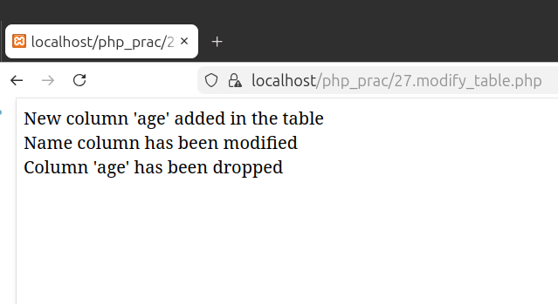
Q28. Write a PHP script, to check whether the page is called from 'https' or 'http'.

<?php
echo "Checking wether protocol is secured or not !<br>";
if(isset($_SERVER["HTTPS"]) && $_SERVER["HTTPS"] == "on"){
echo "----- The page is called from HTTPS ! ----- ";
}
else{
echo "----- The page is called from HTTP ----- ";
}
?>

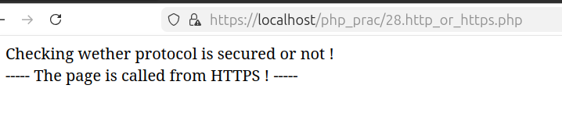
Q29. Write a program to verify text data as per the pattern.
<!DOCTYPE html>
<html>
<body>
<form method="POST">
Enter your Email ID password :
<input type="text" name="txtdata">
<input type="submit" name="submit" value="Check">
</form>
<?php
if(isset($_POST["submit"])){
$text = $_POST["txtdata"];
$pattern = "/^[A-Za-z]+$/";
$pattern2 = "/^[0-9]+$/";
$pattern3 = "/^[a-zA-Z0-9]+$/";
if(preg_match($pattern, $text)){
echo "Consider adding some numbers : Weak password";
}
else if(preg_match($pattern2, $text)){
echo "Consider adding some alphabets : Weak password";
}
else if(preg_match($pattern3, $text)){
echo "You have an Alpha Numeric password : strong password";
}
else{
echo "That doesn't look like a password";
}
}
?>

</body>
</html>

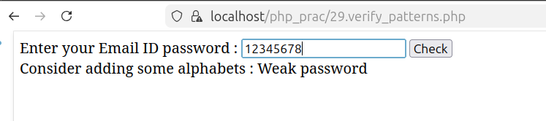
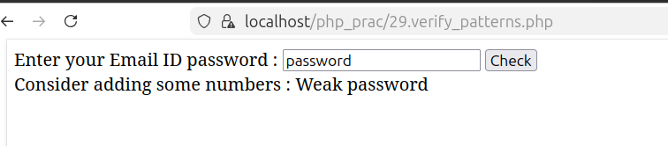
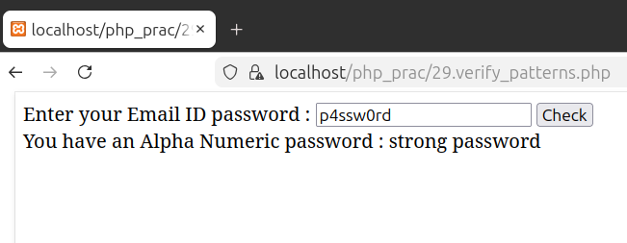
Q30. Modify contents of existing file

